**Module (Bootstrap Basic & Advanced) – 6**

1. What are the advantages of Bootstrap?

Ans: Bootstrap is an open-source CSS framework designed to come up with mobile-friendly, responsive front-end web development.

**Advantages of Bootstrap:-**

* Easy initiation
* Responsiveness
* Highly customizable
* Extremely user-centric
* Cross-browser compatibility
* JavaScript plugins to your rescue
* Updates at the doorstep

1. What is a Bootstrap Container, and how does it work?

Ans: Containers are used to pad the content inside of them, and there are two container classes available: The “.container” class provides a responsive fixed width container. The “.container-fluid” class provides a full width container, spanning the entire width of the viewport

.container

Breakpoints: 576px, 768px, 992px, 1200px, and 1400px.

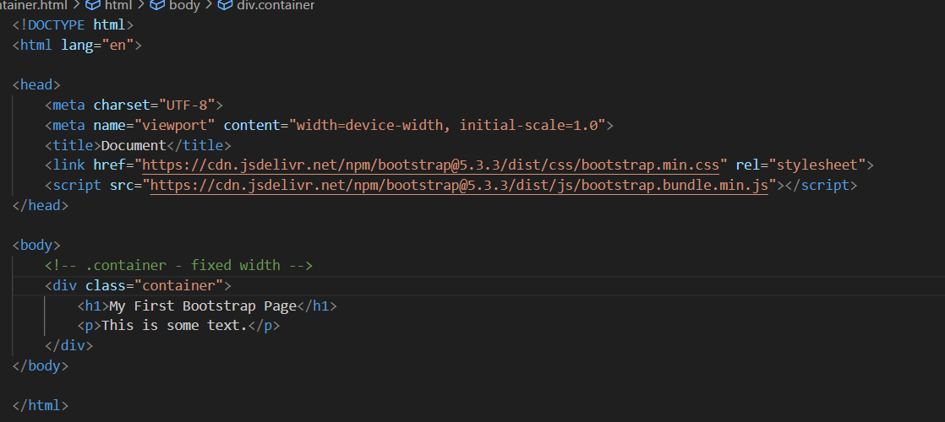

.container-fluid

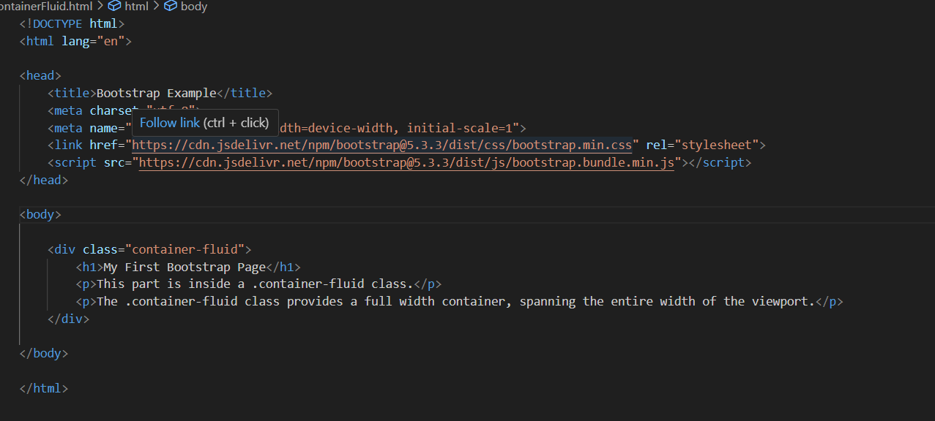

1. What are the default Bootstrap text settings?

Ans: Bootstrap provides a variety of text utility classes to style and align text.

* **Text Alignment:**

.text-left, .text-center , .text-right , .text-justify, .text-nowrap

* **Text Transformation:**

.text-uppercase, .text-lowercase, .text-capitalize

* **Font Weight and Italics:**

.font-weight-normal, .font-weight-bold, .font-weight-bolder, .font-weight-light, .font-italic

* **Text Color:**

Primary: .text-primary, Secondary: .text-secondary, Success: .text-success, Danger: .text-danger, Warning: .text-warning, Info: .text-info, Light: .text-light, Dark: .text-dark, Muted: .text-muted, White: .text-white, Body (default text color): .text-body

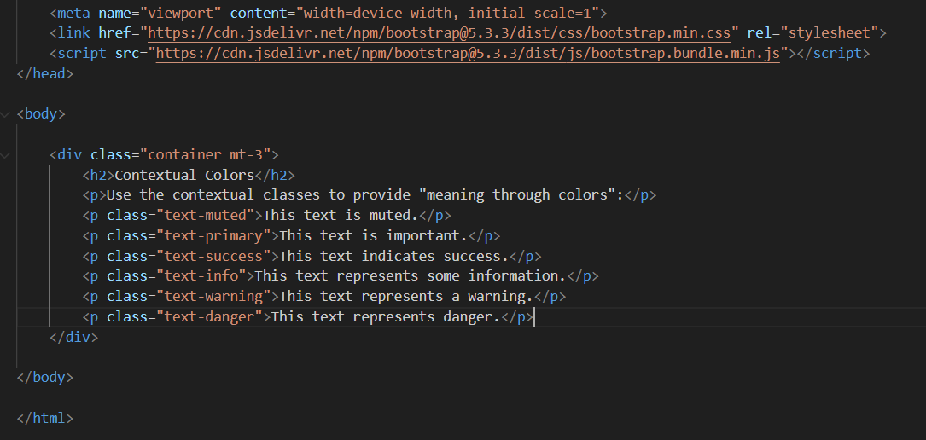

1. What do you know about the Bootstrap Grid System?

Ans: The Bootstrap Grid System is a powerful and flexible layout system that helps create responsive, mobile-first web layouts. The grid system is built on a 12-column layout and supports different grid tiers to target specific screen sizes or device sizes.

**Rows**: Rows are horizontal groups of columns. They ensure that the columns are properly aligned and provide the necessary gutters (spacing) between columns.

**Columns**: Columns are the building blocks of the grid system. They are specified within a row and can span one or more of the 12 available columns.

Its as 6 classes:-

* .col- (extra small devices - screen width less than 576px)
* .col-sm- (small devices - screen width equal to or greater than 576px)
* .col-md- (medium devices - screen width equal to or greater than 768px)
* .col-lg- (large devices - screen width equal to or greater than 992px)
* .col-xl- (xlarge devices - screen width equal to or greater than 1200px)
* .col-xxl- (xxlarge devices - screen width equal to or greater than 1400px)

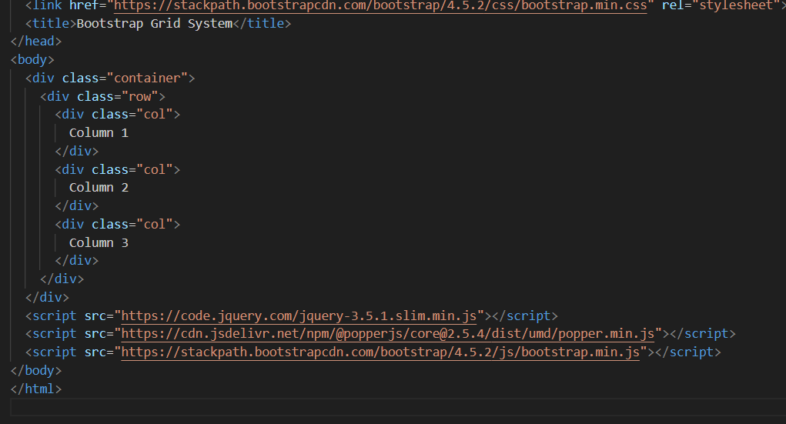

1. What is the difference between Bootstrap 4 and Bootstrap 5?

Ans:

|  |  |
| --- | --- |
| **Bootstrap 4** | **Bootstrap 5** |
| The grid system was flexible but had limitations with custom breakpoints. | Improved grid system with a new gutter system, vertical spacing classes, and support for more responsive columns. |
| Forms had a more basic design and structure. | Adding new form controls like floating labels and improving accessibility. |
| Limited use of CSS variables. | Extensive use of CSS variables, allowing easier customization of theme colors, spacings, and more. |
| Font sizes were fixed. | Introduced responsive font sizes (RFS) to automatically resize typography based on the viewport size. |
| No built-in icon library, relied on external icon libraries like FontAwesome. | Introduced Bootstrap Icons as the official icon library. |
| JavaScript components depended on jQuery. | JavaScript plugins were rewritten to use vanilla JavaScript, improving performance and reducing dependencies. |

1. What is a Button Group, and what is the class for a basic Button Group?

Ans: A Button Group in Bootstrap is a component that allows you to group a series of buttons together on a single line.

To create a basic button group in Bootstrap,

* ‘.btn-group’ class.

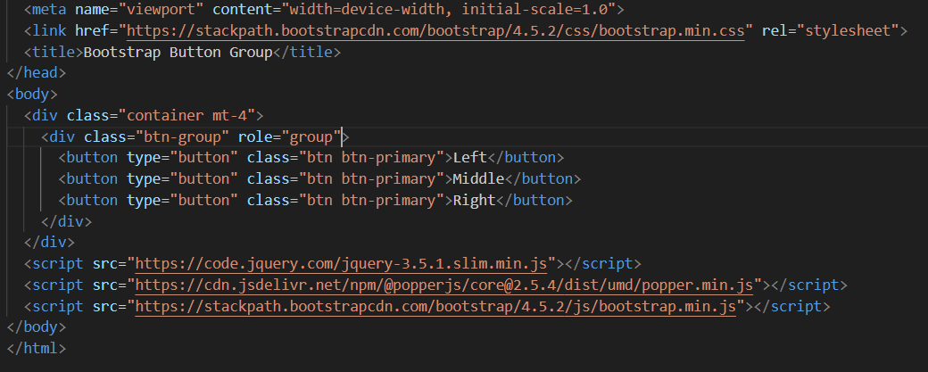

**Types of ButtonGroups:-**

* Vertical Button Group : “.btn-group-vertical” class
* Nesting Button Groups & Dropdown Menus :

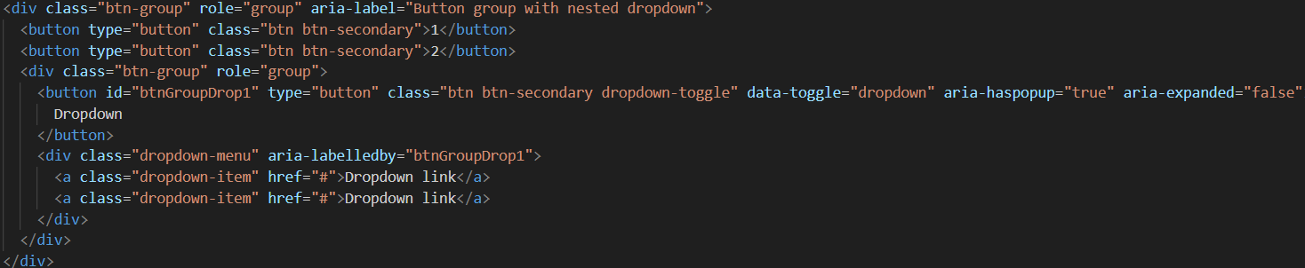

1. How can you use Bootstrap to make thumbnails?

Ans: 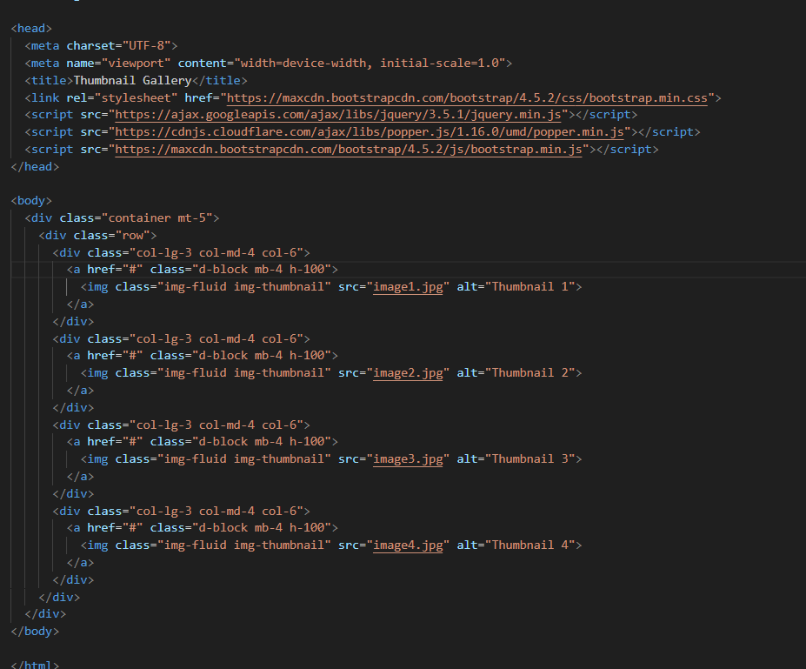

1. In Bootstrap 4, what is flexbox?

Ans: In Bootstrap 4, flex box is used to control the layout and alignment specification of Bootstrap 4 components.

**example:**

* .d-flex makes the container a flexbox container.
* .flex-row arranges items in a row.
* .justify-content-between distributes space between items.
* .align-items-center aligns items vertically in the center.
* .flex-wrap allows items to wrap to the next line if necessary.

1. How can one create an alert in Bootstrap?

Ans:

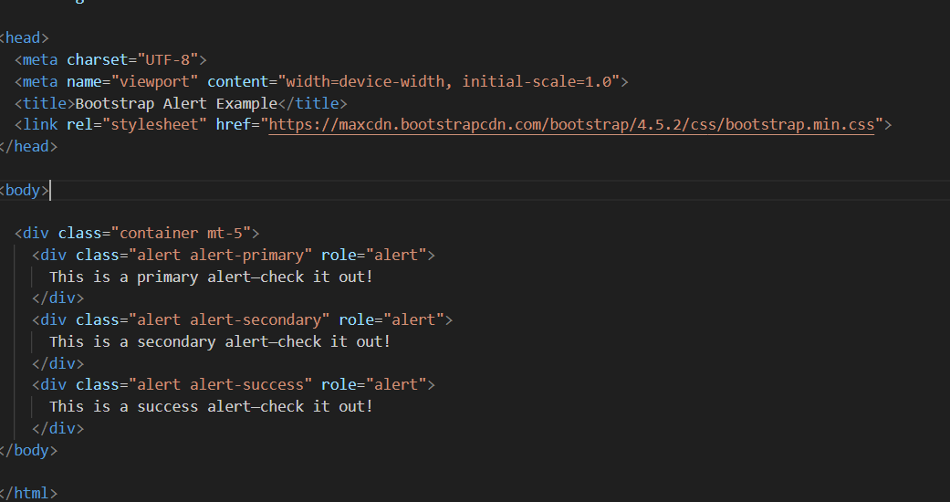

1. What is a bootstrap card and how would you create one?

ANS: 